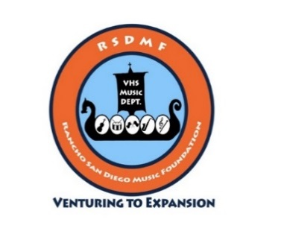
Rancho San Diego Music Foundation (RSDMF)
A 501(c)(3) Not-For-Profit-Organization - Tax ID# 75-3221534
Valhalla High School
1725 Hillsdale Road
El Cajon, CA 92019
Supporting the Instrumental Music Programs at Valhalla High School

Date: ___________________

Hello Community Neighbor: ______________________,

Hope this letter finds you well. Plans are well under way for our big annual Valhalla High School Field Tournament on October 21, 2023. This event raises much needed funds for the music department programs for our 2023/2024 school year. We have a hospitality area where our VIPs will be having their lunch or dinner breaks. We will also have our concession stand area where we serve a lot of guests food, snacks and drinks.

The event provides funds for music coaches, music purchase, competition fees, uniform, and instrument repairs. All of these expenses are unfortunately no longer covered by the school budget but fall onto the parent’s donations and fundraising activities lead by the RSDMF support organization.

RSDMF would like to ask our community members to please help out and donate an item or two such as gift cards, certificates for services, or actual merchandise for the Valhalla High School Field Tournament. This donation will help our local students realize a full experience in their musical development. Many of these students will go on to colleges with music as a major and eventual music careers.

Please help us make these dreams come true. The attached form should help assist in the process.

Feel free to look at our students performing in the ‘Gallery’ section of www.valhallainstrumentalmusic.com

Also view our concert and other events at www.valhallamusic.org

Thank you very much for your support.

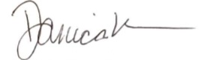

Danica Roseman
President RSDMF
www.valhallamusic.org

Rancho San Diego Music Foundation (RSDMF)
Donation Form
Please check one:

______I will send my donation in the mail. (addresses at bottom of page)

______I need to arrange a pick-up of the donation. (see VHS contact information below)

______I will drop-off the donation at Valhalla HS Band Room or arrange another location

Name of Company or Individual Donor: ____________________________________________________

Company Contact Name/Title: ___________________________________________________________

Address: _____________________________________________________________________________

City: ____________________________State: ________________Zip: ___________________________

Email: ____________________________Contact Phone: ______________________________________

Item(s) donated:

_____________________________________________________________________________________
Please be specific, this information may be used in the event program or other promotional materials

Estimated Value of my donation: $______________

Mailing Address:  RSDMF  c/o Valhalla High School  1725 Hillsdale Road  El Cajon, CA 92019 | VHS Contact Information (sending to other than RSDMF address):

